SITE CHARACTERISTICS

To this point, terminology for describing and naming horizons has been discussed. The other part of a soil description is characteristics of the site where the soil is found. These are not really part of the soil, but they may have had a great influence on development of the soil and may also greatly influence interpretation for intended use. Thus, some or all of the following characteristics should be included in the soil description.

Properties to consider include:

Location: The most comprehensive description and data set for a soil is useless unless the location where the description and samples were collected is known with reasonable accuracy. As with a business, the three most important things in any study of soil are location, location, and location. Many methods can be used to specify location including latitude and longitude or other coordinate system; township, range, and section (U.S. only and all parts of the country were not surveyed by this system), meets and bounds (distance and direction from a known point), etc. The availability of geo-positioning systems (GPS) has simplified determination of location.

Climate: Climate is one of the major driving forces in soil development and also often has a major influence on interpretation of soil use and management. Depending on the skill of the describer and needs of the study some or all of the following should be considered. Temperature (annual and seasonal), rainfall (annual and seasonal distribution), potential evapotranspiration, wind speed, etc.

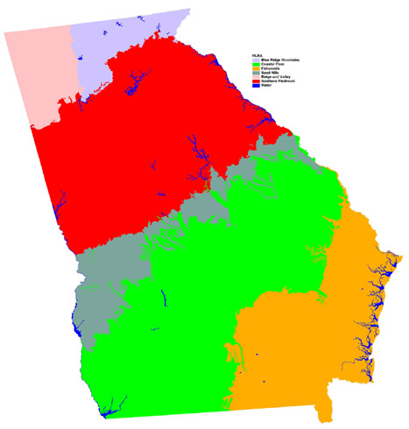
Vegetation: also one of the major factors that influence soil development and properties. Describe in as much detail as possible including species, annual productivity, etc.

Land Use: cropland, forest land, rangeland, etc.

Physiographic province: a broad descriptor of the general region in which you are located. Normally these descriptors are based on rock type, topography, and climate. Various maps are available that delineate these regions in this and other countries. In Georgia, eight major physiographic regions are commonly identified; Sand Mountain, Ridge and Valley, Blue Ridge Mountains, Southern Piedmont, Sand Hills, Blacklands, Coastal Plain, and Atlantic Coast Flatwoods.

Geomorphic position: The geomorphic position on which the soil is located. Position may help determine parent material type and properties, drainage, and other properties. Common geomorphic surfaces encountered in unglaciated humid regions include floodplain (can be divided into components within the floodplain such as natural levee or back swamp), low terrace, high terrace, hillslope, dune, sand ridge, and many others. Many other types of surfaces are found in areas with different climate and geologic history.
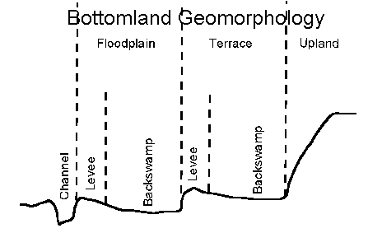
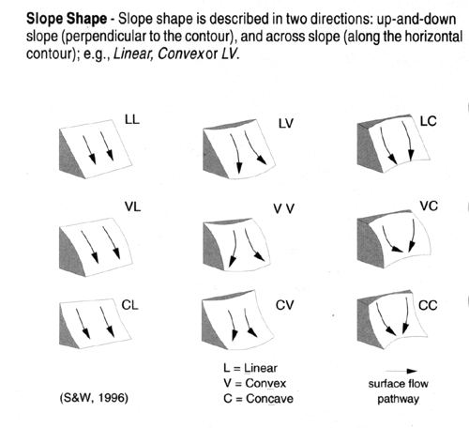
Slope: The maximum slope at the point the soil is located in percent (or degrees). Influences runoff, erosion, and hydrologic properties, and may have influenced degree and pathway of soil development.

Slope shape: Influences slope stability, runoff, and erosion. Describe shape (convex, plane, or concave) parallel and perpendicular to contours.

Aspect: Direction in which the slope faces when looking downslope. Specify compass point or degrees. In steep areas, aspect influences temperature and evapotranspiration (ET). Soils on north and east facing slopes are cooler and wetter (lower ET) in the northern hemisphere.

Geomorphic Component: Three dimensional descriptors of parts of landforms or microfeatures that are best applied to areas. Unique descriptors are available for Hills, Terraces, Mountains, and Flat Plains; e.g., (for Hills) nose slope.
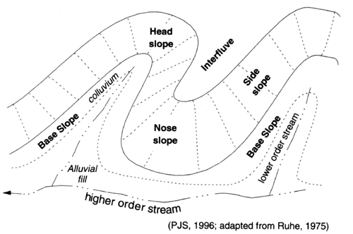
The geomorphic component is hard to determine and seldom used in rolling landscapes such as the Southern Piedmont. It is more commonly used in steeper areas with better defined coves and noses. Headslopes are convergent, collect runoff and throughflow, and are the wetter parts of the landscape, In contrast, noseslopes are divergent and are the drier part of the landscape.

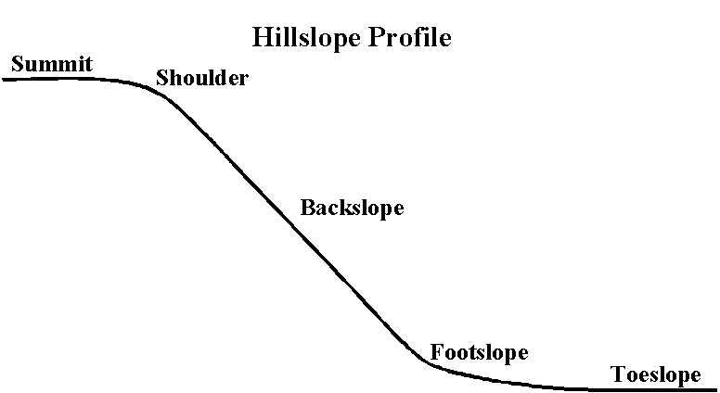
Hillslope component: A hillslope can be divided into five components; summit, shoulder, back slope, foot slope, and toe slope. Broad flat summits often have poorly drained soils while convex summits are commonly well drained. The shoulder position is the driest position (convex slope and most runoff) and often has the least developed soils because of less water moving through the profile. The lower slope positions tend to be the wetter positions and may accumulate sediment or soluble components transported with throughflow.

Elevation: The height of a point on the Earth’s surface, relative to mean sea level (msl)

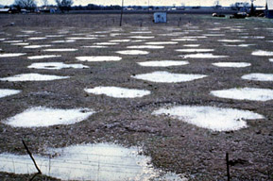
Microrelief: describes differences in surface elevation measured over distances of meters. Many features occur and many terms are available to describe these features; gilgai (mounds and swales at the surface of Vertisols caused by shrink-swell; photo at right), mima mounds (small diameter, low mounds that occur on some prairie soils), microdepressions, tree throw features, etc.

Parent Material: identify kind or kinds. The parent material may affect many of the soil’s properties including particle size, mineralogy, and degree of development. Specify as many characteristics as is possible.
Residuum - soil is derived from rock like that underlying the soil; identify rock type, sandstone, schist, etc., if possible.
Alluvium - sediment deposited by streams.
Marine sediments - sediments deposited from the sea; normally these materials have been reworked by tides and currents.
Lacustrine deposits - sediment deposited under lakes.
Volcanic ash - as the name implies.
Loess - windblown sediments that are predominantly silt sized
Eolian sand - sand-sized windblown material
Glacial drift - material moved and deposited by glacial processes (general term); glacial till, glacial outwash, etc. are more specific
Colluvium - material moved and redeposited under the influence of gravity
Peat - organic material with most of the material sufficiently fresh to identify plant parts.
Muck - organic material that is decomposed to the point that plant parts cannot be recognized.
Many other types and terms are recognized.

