INFILTRATION AND RUNOFF PROCESSES IN RELATION TO EROSION CRSS 4580/6580

Two major concepts explaining overland flow (OLF):

1) “infiltration excess OLF”: classical Hortonian approach (Horton, 1930’s)

: near-surface process (A horizon): dry soil wets to saturation under rainfall, once rainfall intensity exceeds hydraulic conductivity of A horizon, runoff begins

: depends on properties of A horizon only, and rainfall intensity.

: predicts that all parts of (uniform) catchment should generate OLF similarly

2) “saturation excess OLF”: variable source area (VSA: Hewlett, 1960’s)

: assumes generally that surface infiltration rate > rainfall intensity (2-5 cm/h)

: subsurface flow re-distributes water within catchment, saturation at surface leads to OLF

: only areas low in catchment generate OLF; this area expands and contracts with rainfall amt

: depends on whole pedon properties (WHC, K-sat), as well as landscape position

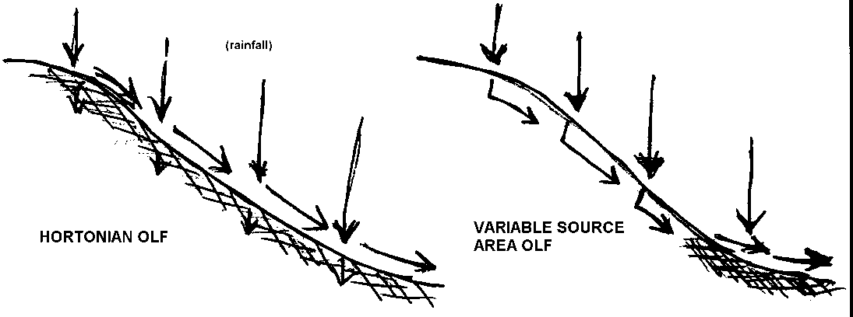

Conceptual diagrams of Horton vs. VSA runoff models



-> WHICH process occurs would seem to depend a LOT on whether Rainfall Intensity (RI) is > or < soil Infiltration Rate (IR)…. (most of the time)

: if IR > RI: VSA  
: if RI > IR: Hortonian

Actual IR’s for most soils are not really known: depends on a lot of things…

*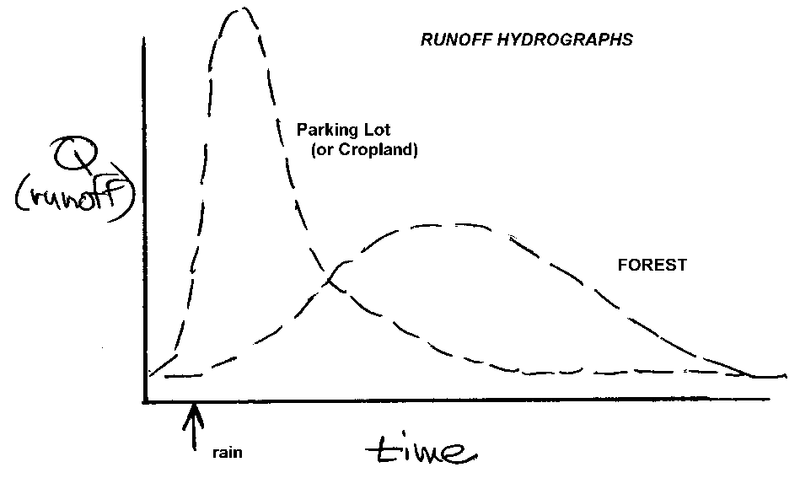Evidence from hydrographs:*

--forested watersheds tend to have broad, flattened discharge (Q) that suggests VSA type processes

--“impervious” surfaces have very “flashy” Q (IR=0)

--cropland (bare soil) TENDS to be pretty flashy: RI>IR for many storms…

**Soil Infiltration Rates:**

: traditional estimates based on texture (sands=high, clays=low); but: structure is important, also

: many ways to measure, none very satisfactory (lab permeameters, rings in field)

: assumption is that once soil gets saturated, IR = K-sat for that soil, and is a constant

: rainfall simulation expts on bare soils show this is not true for many soils:

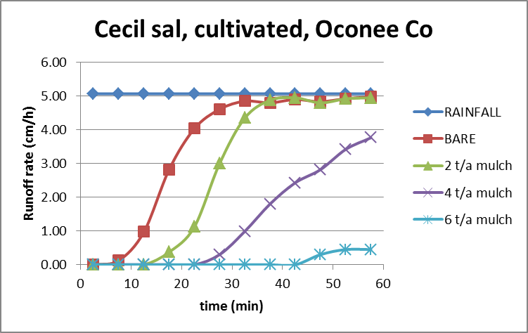

Small runoff box simulation, 5 cm/h rainfall rate, bare soil and 3 straw mulch rates.

: on bare soil: 90%+ runoff after 20-30 min at moderate RI

: adding surface mulch greatly reduces runoff, in proportion to % of surface covered by mulch

***Soil Crusting:*** formation of compacted, low permeable layer at soil surface (due to raindrop impact)

Observations:

1) crusting does not occur on sand, loamy sands: only sandy loam and finer textures  
2) composed of thin (mm) layer of fine (silt, clay) particles compacted at surface, filling all larger soil pores (macro-pores=water flow)  
3) tendency of soil to crust is related to aggregation and certain chemical properties

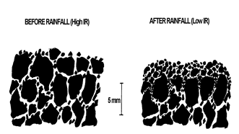

Conceptual idea of soil crust formation during rainfall: aggregate disintegration due to raindrop impact results in fine particles clogging water trans-mission pores, leading to lower infiltration

Capacity to resist crusting depends very largely on good soil aggregate stability:

--macro-level (2-50 mm): roots, fungal hyphae, soil animals bind sand, smaller aggregates together  
 --meso-level (0.01-2 mm): humic polymers binding silts, clays into smaller aggregates  
 --micro-level (<0.01 mm): clay flocculation—polyvalent cations, moderate salt levels: micro-aggregates

Some Definitions:

--*slaking*: disintegration of aggregates when placed in water (aggregates NOT water-stable)  
--*dispersion*: repulsion of clay particles to form a suspension in solution (OPPOSITE of flocculation)  
: *spontaneous dispersion*: 2:1 clays form suspension in absence of energy input  
(due to energy of swelling in interlayers, at low salt content and/or presence of Na ions)  
: *mechanical dispersion*: 1:1 clays disperse within input of some energy source

(once clays separate due to energy input, they form a stable suspension)

Traditionally, crusting was thought to occur only on soils of semi-arid regions with 2:1 clays and high Na (poor aggregation, spontaneously dispersive). Most forest soils in humid regions have good macro-aggregation and are flocculated at the colloid level. In the Southeastern US, however:

--water-stable aggregates common under forest, but rapidly degrade when cultivated  
--high temps cause humus to rapidly oxidize under cultivated conditions  
--clays mechanically disperse due to low salt levels, low humus  
--very high energy input in rainfall

CONCLUSION:  
 1) Under forested conditions, SE US soils are well-aggregated and protected from raindrop energy input; as a result, they have high infiltration rates and runoff generation likely follows the VSA model.

2) When cultivated, these same soils have poor aggregate stability; under rainfall conditions they slake and mechanically disperse, forming crusts that have low permeability, and thus runoff follows a more Hortonian process. Runoff rates can be very high, and sheet, rill and gully erosion are an immediate consequence.