SOIL COLOR
Color is an obvious property and commonly used descriptor of soils, i.e. "black soils", "red soils", "brown soils", etc. Color of surface horizons is an important differentiating criterion in Soil Taxonomy. In addition, color can be used to infer species of Fe and Mn minerals present in the soil, stage of soil development, and seasonal saturation of horizons.
Source of Soil Color:
The color of soil material is because of the color of uncoated mineral grains and/or coatings on mineral grains or other features. Mineral grains can be any color, but quartz and clay minerals, which are the most common minerals found in soils, are commonly white to gray.
The color of coatings depends on the coating's composition. Organic matter is brown to black and commonly causes horizons near the soil surface to be darker colored than underlying subsoil horizons. Organic matter and may also be found as dark accumulations or coatings in subsoil horizons.
The color of subsoil horizons is most often the color of Fe and Mn oxides and oxyhydroxides coating grains.
Geothite (α-FeOOH) is yellowish brown and is the most common Fe mineral in soils.
Hematite (Fe₂O₃) is red and is a very effective pigmenter because of its small particle size. Red subsoil horizons often have more geothite than hematite but appear red because the hematite overshadows the color of the goethite.
Lepidocrocite (γ-FeOOH) is orange to yellowish orange and is most often found in seasonally saturated soil horizons. Rapid oxidation of reduced Fe favors formation of lepidocrocite over formation of goethite.
Mn oxides are commonly black. Like hematite, Mn oxides are effective pigmenters because of their small particle size. Black ped coatings and nodules are often found in subsoil horizons, but although these coatings are often described as Mn coatings and nodules, most of these features contain more Fe oxides than Mn oxides. They appear black because of the pigmenting effectiveness of the Mn oxides.
Soil Color Determination:
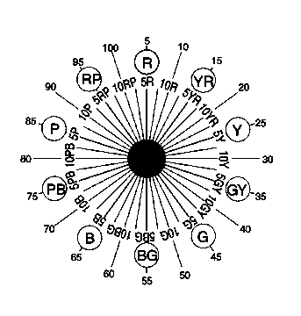
The Munsell system is universally used to describe soil color. It has three components; hue, value, and chroma.

Hue - (page) measure of chromatic composition of light reaching the eye. Hue is identified by the hue sector and a step, based on a scale of ten, within that sector. For example, the hue in the middle of the red sector is called five red, and is written 5R. The zero step is not used, so there is a 10R hue, but no 0 R, i.e. 10RP (red-purple) is 0R. The steps in the R and YR sectors are 2.5R, 5R, 7.5R, 10R (0YR), 2.5YR, 5YR, 7.5YR, 10YR (0Y). With each step in this sequence, more yellow is added to the color.



Value - (vertical scale) degree of lightness or darkness of a color. The scale of value ranges from 0 for pure black to 10 for pure white. Soil color generally has values that range from 2 to 8.


Chroma - (horizontal scale) relative purity or strength of the spectral color. Chroma is the degree of departure of a color from the neutral color of the same value. Colors of low chroma are sometimes called weak or dull, while those of high chroma are said to be highly saturated, strong or vivid. If a vivid yellow paint were gradually mixed, a little at a time, with a gray paint of the same value, a series of gradually changing colors would develop that increase in chroma. Chroma is arbitrarily scaled with 0 representing neutral colors (no hue; a photographers "gray card"). There is no end to the scale. The chroma for normal reflecting materials extends beyond 20 in some cases. Fluorescent materials may have chromas as high as 30. Soil colors generally have chroma of 8 or less.
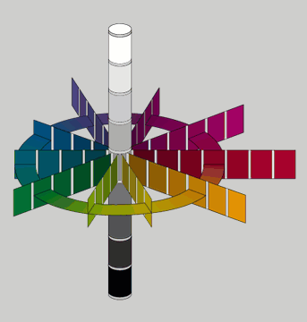
The complete Munsell notation for a chromatic color is written symbolically: H V/C. For a red horizon having a hue of 2.5YR, a value of 6 and a chroma of 8, the complete notation is 2.5YR 6/8. The notation for a neutral color is written: N V/. (The chroma of a neutral color is zero, but it is customary to omit the zero in the notation.) The notation N 2/ denotes a very dark neutral, while N 9/ denotes a white, a very light neutral. The notation for a middle gray is N 5/.

Mottles

Many soil horizons have more than one color. The dominant color is referred to as the matrix color. Other less abundant colors in the horizon may result from a variety of processes. The most common cause of different colors within a horizon is seasonal saturation with water and associated reduction and oxidation of Fe and Mn. These mottles that result from seasonal saturation are called redoximorphic features (discussed below). There may be, however, zones of color that is different from the matrix not associated with redox and seasonal saturation. These different colored areas are called mottles. Mottles do not include coatings on rock fragments, ped faces, infilled root channels, and other features than can be otherwise identified.

Mottles are described in terms of their abundance, size, contrast, and color. Mottle shape is an optional descriptor.

Redoximorphic Features:

Features within a horizon whose color is the result of reduction, oxidation, and movement of Fe and Mn associated with seasonal saturation.

Redox features are described with the same criteria as mottles - abundance, size, contrast, and color. In addition, the type of redox feature should also be specified.

Type:

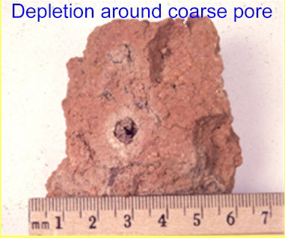
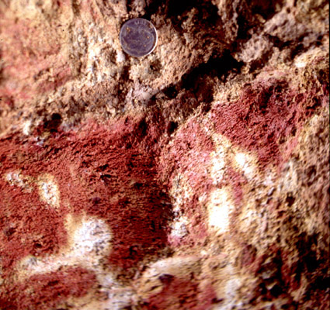
Redox depletions - areas in the soil with lower chroma than the matrix caused by depletion (loss) of Fe and Mn from the area. The lower chroma (grayer) color of the redox depletion is the color of uncoated mineral grains (gray to white) or because the grain coating is thinner and more of the color of the mineral grain can be seen through the coating. Redox processes can also lead to the dissolution of clay minerals and zones in the soil that are depleted in both Fe and clay. These zones are less common than Fe depletion but are also redox depletions.
Redox concentrations - areas with higher chroma (and often value) and redder hue than the matrix caused by concentration of Fe and Mn in the area. These may be soft or hard depending on degree of development, amount of Fe and Mn in the concentration, recrystallization, mineral species, and other factors.
Depletions in a red matrix
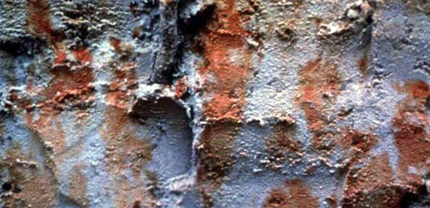
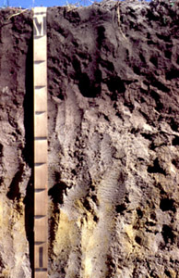
Concentrations in gray matrix
Pedon with coarse concentrations in horizon at about 85 cm

Reduced matrix - areas in the soil that contain reduced Fe. These areas are often bluish gray and will change color (become browner) upon exposure to air.

Other characteristics of mottles and redox features can be described if they are important or diagnostic. These characteristics include shape, boundary between the redox feature and the matrix, location (ped surface, along root channels, etc.), composition, and other characteristics.

Importance of color:

Color has limited importance on its own. Its usefulness is in its relation to other soil properties and interpretations such as organic matter content, seasonal saturation, etc.

Formation of Redoximorphic Features

Redox concentrations and depletions form by movement of Fe and Mn from one part of the soil to another. The mobility of Fe and Mn in soils is related to Fe and Mn reduction caused by saturation with water. Oxidized Fe and Mn (Fe³⁺ and Mn⁴⁺) are essentially insoluble in water and immobile in soils. Reduced Fe and Mn (Fe²⁺ and Mn²⁺) are soluble in water and can move from one part of the soil to another by mass flow and diffusion.

If O₂ is present, it is used as the electron acceptor for microbial respiration. When the soil is saturated with water, microbial activity depletes oxygen dissolved in the water because of the slow diffusion rate of oxygen into water. If oxygen is not available, faculative anaerobic bacteria (Thiobacillus spp.) have the ability to use other elements and ions as electron acceptors in respiration. The addition of electrons to the element or ion "reduces" the element or ion (lowers the valence) and changes its chemical properties.
The order in which ions are used as electron acceptors depends on the energy of the reactions. The redox reactions are “poised”, i.e. the most energetically favorable ion will be used as an electron acceptor (reduced) as long as it is available. Oxygen is the most energetically favorable and will be used as long as it is available. When all of the oxygen has been used, nitrate will be next, etc.
Order of reduction in soils
O₂ → O⁻²
NO₃⁻¹ → N₂O or N₂ (denitrification)
Mn⁺⁴ → Mn⁺²
Fe⁺³ → Fe⁺²
SO₄⁻² → S⁻² (H₂S) (marsh or "rotten egg" gas)
HCO₃⁻¹, CO₂ → CH₄ (methanogenesis)
When Fe and Mn become reduced, they are soluble in water, and thus, can move by mass flow and diffusion. Reduced Fe and Mn become oxidized immediately upon exposure to oxygen. When they become oxidized, they are no longer water soluble and mobile.

Movement of Fe from reduced to oxidized zones causes loss (depletion) of Fe from the reduced zone and concentration of Fe in the oxidized zone. Depletion of Fe removes the Fe coatings on grains that give the soil material its yellowish, brownish, or red color. Thus, color of the Fe depleted zone is that of uncoated mineral grains (dominantly quartz and clay minerals that are white to gray). Reduced Fe compounds are also commonly gray, but if the horizon is not saturated, no reduced Fe is present. Addition (concentration) of Fe in the oxidized zone causes the zone to be redder than the matrix color of the horizon.

The movement of Fe may be between microsites within a horizon, from one horizon to another within a pedon, or across the landscape. Oxidized microsites serve as a sink for reduced Fe, i.e. because site is oxidized, a diffusion gradient exists between reduced areas and oxidized areas. There is a concentration of Fe²⁺ in reduced zones while the concentration in oxidized zones is 0, which establishes the diffusion gradient. This gradient causes Fe to move from reduced micro-sites (redox depletions) to oxidized microsites (redox concentrations).


Because reduction is microbially driven, four conditions must be present in the soil for reduction to occur and for redox features to form. These are:
- saturation with water to exclude oxygen,
- presence of facultative anaerobic bacteria (almost always true),
- presence of organic matter as a food source for the bacteria, and
- presence of Fe and Mn to form visible features. Very few soils have so little Fe that visible redox features will not form if the other conditions are present. One exception are very sandy soils such as those that occur in the the Flatwoods region of Georgia.
Because organic matter is needed for microbial activity, redox feature formation is usually slower in subsoil horizons than in surface horizons. Also, redox depletions in subsurface horizons often occur around dead plant roots and other sources of organic matter as food for microbes.
The other criterion necessary for formation of redox features is time. There is a time lag between saturation and Fe reduction during which dissolved oxygen and nitrate must be used up. The time between saturation and reduction depends on the amount of organic matter in the horizon. More organic matter means more food for the facultative anaerobic bacteria and faster increase in the bacteria population. Thus, Fe reduction will occur more rapidly in horizons near the surface with higher organic matter content. For subsoil horizons, most data suggest the time lag between saturation and Fe reduction is two to three weeks but can be longer. Periods of saturation less than those necessary for Fe reduction to occur will not result formation of redox depletions and concentrations.
In addition, water movement through soils is slow, diffusion is even slower, and the amount of Fe that moves during any one period of reduction is small. Thus, for visible redox features to be present, the soil must have gone through repeated cycles of saturation and reduction over a period of 10's to 100's of years.

SOIL TEXTURE

Texture refers to size and relative abundance of mineral particles comprising a soil horizon or soil sample.

Soil separates: individual size groups of mineral particles.

USDA Divisions of Soil Separates
Separate |  | Size
 |  | (mm)
Stones |  | >250
Cobbles |  | 250-76
Gravel |  | 76-2
Sand (s) |  | 2-0.05
 | Very coarse sand (vcos) |  | 2-1
 | Coarse sand (cos) |  | 1-0.5
 | Medium sand (s) |  | 0.5-0.25
 | Fine sand (fs) |  | 0.25-0.1
 | Very fine sand (vfs) |  | 0.1-0.05
Silt (si) |  | 0.05-0.002
Clay (c) |  | <0.002

Other systems can be used to categorize sizes of particles.

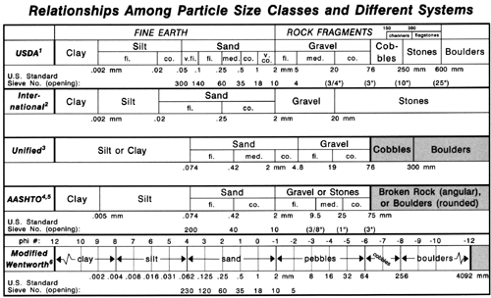

Engineers -
sand-silt boundary - 0.074 mm
silt-clay boundary - 0.005 mm
Geologists - phi scale or
sand-silt boundary - 0.0625 mm
International scale
sand - 2-0.02 mm
silt - 0.02-0.002 mm
clay - <0.002 mm

Textural Triangle and Textural Classes

Particles <2 mm in size are often referred to as the fine earth fraction. For these classes of particles (sand, silt, and clay), a system has been developed that groups ranges of percentage composition of the three separates into textural classes. This system is called the textural triangle. We will learn to determine textural class by feel. However, it is important to remember that a textural class represents a specific range of percentages for sand, silt, and clay. It is usually a good practice to attempt to estimate percentage of sand and clay (a good soil scientist can estimate sand and clay percentage within about 4% of the laboratory measured value) and determine if your estimates fall within the textural class you have estimated.
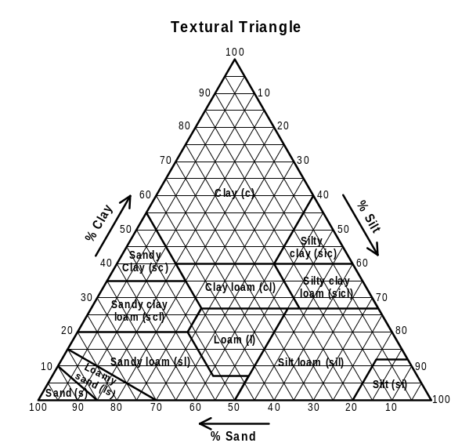
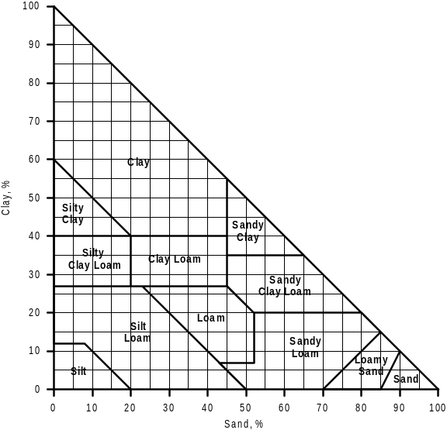
Textural Class Names and Abbreviations

sand (s) | silt (si) | loam (l)
loamy sand (ls) | silt loam (sil) | clay loam (cl)
sandy loam (sl) | Silty clay loam (sicl) | clay (c)
sandy clay loam (scl) | Silty clay (sic)
sandy clay (c)
Sand, loamy sand, and sandy loam textures are modified by the dominant size class of the sand (very fine, fine, or coarse). If the dominant sand fraction is medium, no modifier is used.
examples
fine sandy loam (fsl)
coarse sandy loam (cosl)
loamy very fine sand (lvfs)
sandy loam (sl)

Textural modifers for rock fragments (gravel, cobbles, and stones)

Volume % Fragments | Modifier Used
<15 | none
15-35 | gravelly, stony, bouldery, flaggy, i.e. gravelly loam (grl)
35-60 | very added, i.e. very gravelly loam (vgrl)
>60 | extremely added, i.e. extremely gravelly loam (exgrl)

Importance

Many soil interpretations are based on texture or by combining texture with other properties such as structure or clay mineralogy. Many pedogenic pathways and processes are inferred from texture and the distribution of texture with depth.

SOIL STRUCTURE

Soil structure refers to the aggregation of primary soil particles into compound particles. The cohesion within structural units is greater than the adhesion among units. Thus, under stress, the soil mass tends to rupture along predetermined planes or zones.

Individual natural structural unit is called a ped if it is the result of soil-forming processes. Clods or fragments are due to other processes (tillage, etc.).

Structure is described in terms of grade, size, and shape.

Grade - distinctness or degree of expression of peds. Criteria for evaluation include the amount of soil material in a horizon that is recognizable as being part of structural units.

weak - The units are barely observable in place. When disturbed, the soil parts into a mixture of whole and broken units and much material that is not part of any structural unit.

moderate - The units are well formed and are evident in undisturbed soil. When disturbed, the soil parts into a mixture of many whole units, some broken units, and a small proportion of material that is not in structural units.

strong - The units are distinct in undisturbed soil. They separate cleanly when the soil is disturbed. When removed, the soil separates mainly into whole units.

Shape:
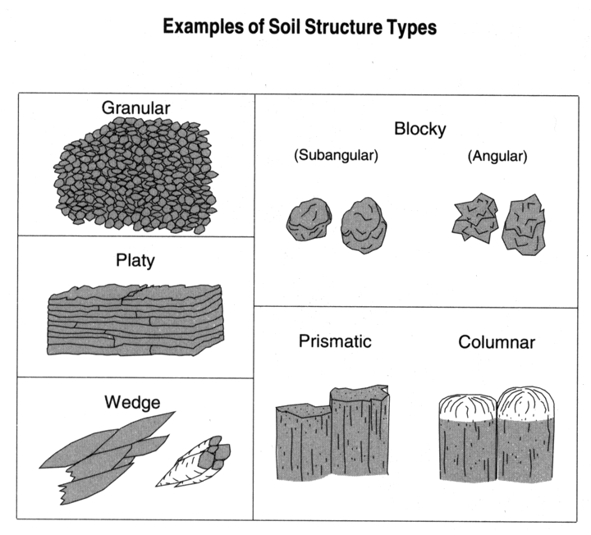
platy - units are flat and plate like

prismatic - units are bounded by flat or slightly rounded vertical faces. Units are distinctly longer vertically. Vertices are angular or subrounded. Tops are indistinct and normally flat.

columnar - similar to prisms except that tops are very distinct and are rounded.

blocky - units are block like and nearly equidimensional

angular blocky - faces intersect at relatively sharp angles.

subangular blocky - faces are a mixture of rounded and plane faces and the angles are mostly rounded.

granular - units are spherical and are bounded by curved or very irregular faces that are not casts of adjoining peds.

Not all soil horizons have structure. These are referred to as structureless (grade) and either massive (soil has cohesion) or single grained (soil falls apart into individual particles, i.e. sand).

There are horizons in which small structural units are aggregated into larger structure with the same or, more commonly, a different shape. This is referred to as compound structure and is described as "moderate coarse prismatic parting to moderate medium subangular blocky structure". "Parting to" is the key phrase.

Structure formation in surface horizons is mainly due to biologic processes. Organic compounds from root exudates, microbial exudates, and other sources bind soil particles into larger units. Granular structure is common. At least a part of the granular structure is fecal pellets from earthworms, insects, and other critters.

Structure forms in subsoil horizons from shrink-swell as the soil wets and dries. Even kaolinitic soils have a small amount of shrink-swell. Once planes of weakness are formed, the soil will continue to fail along these planes or faces. Fe and Al oxides are effective cements that help to strengthen the expression of structure. As the soil develops, Fe and Al oxides are released through mineral weathering and Fe oxides are translocated to subsoil horizons. Thus, structure normally becomes better expressed as soil development proceeds. Also, as the soil develops, clay, Fe, and organic matter may form coatings on ped surfaces further enhancing strength and expression of structure.
Structure may have a large impact on rates of water movement through soil horizons, ease of tillage, aeration, and other properties. In soils with low potential for shrink-swell such as the kaolinitic soils common over much of Georgia and the Southeast, macropores are present between peds. Thus, well developed structure in a horizon results in an extensive network of macropores that can move water through the horizon under saturated conditions. Too much structure may be detrimental. Strongly expressed structure can cause clayey soils to behave as if their texture was sand or a fine gravelly texture. This may result in severe water retention problems that would not be expected from the soil's texture.

"Response of soil to management may depend as much on its structure as on its fertility."

Impact of structure on saturated hydraulic conductivity (K_{s})

Horizon | Depth | Structure | Texture | K_{s}
 | cm |  |  | cm/h
Bt | 60 | moderate subangular blocky | clay | 16.7
BC | 90 | weak subangular blocky | sandy clay loam | 5.8
 | 120 | massive | sandy loam | 3.5
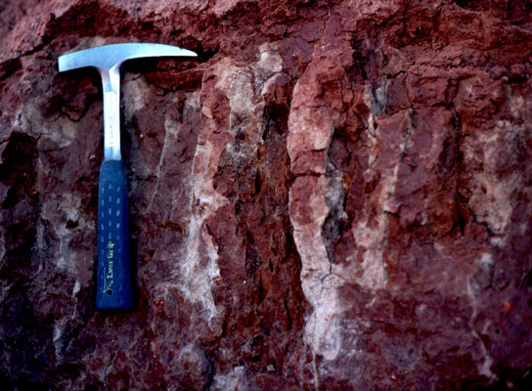
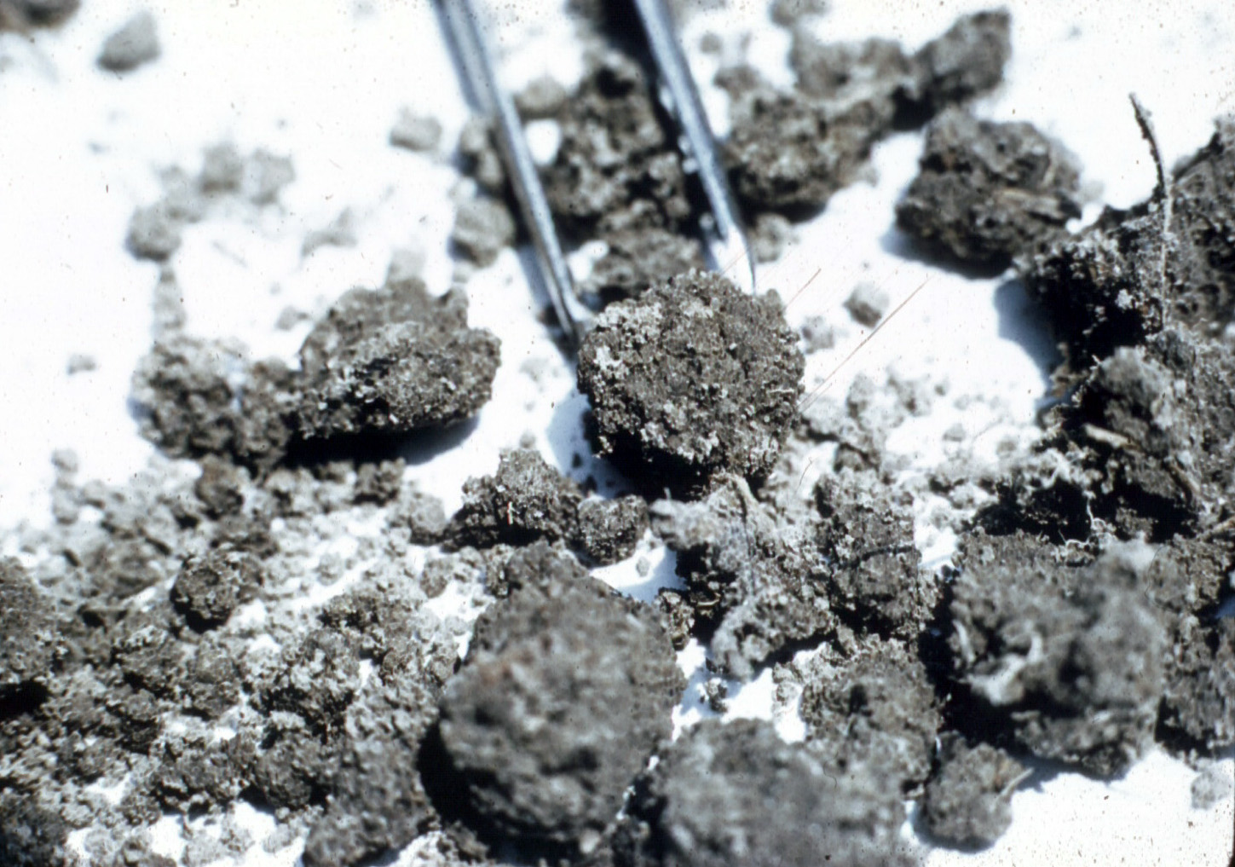
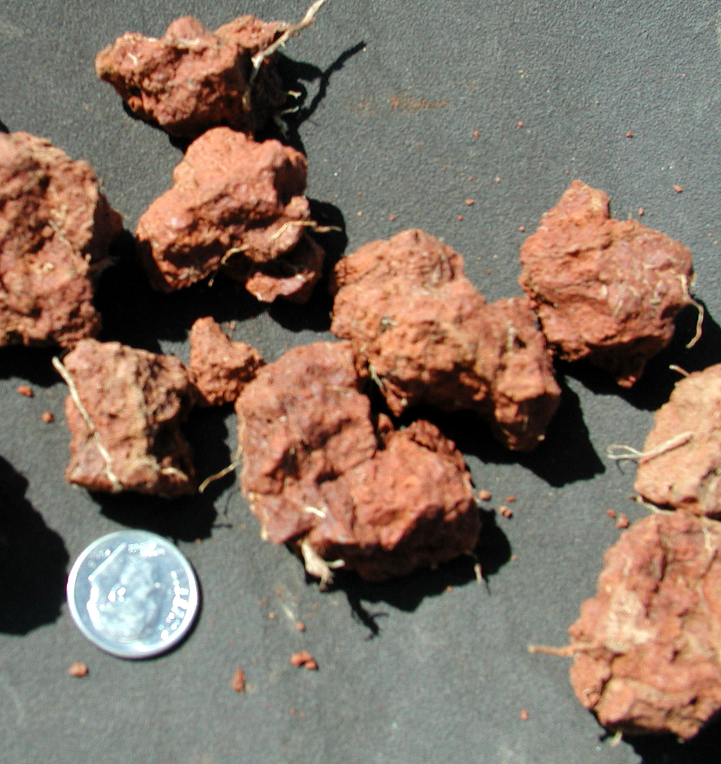
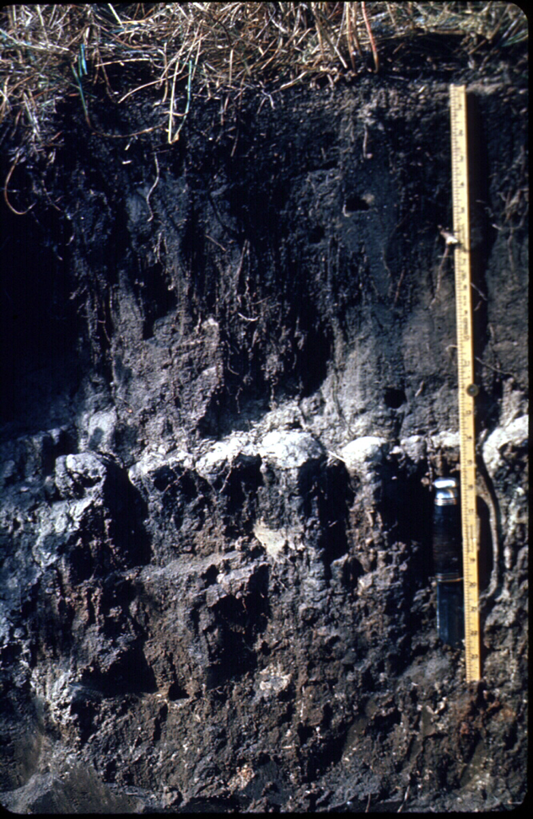
Prismatic structure
Granular structure
Subangular blocky structure
Columnar structure

SOIL CONSISTENCE

Consistence or rupture resistance describes degree of adhesion and cohesion of the soil material in a horizon or the resistance to deformation under pressure. The adhesion and cohesion of the soil depends on its moisture state. Dry soil is more difficult to deform than moist soil. Thus, different consistence terms are used for different moisture states (moist and dry).

Terms for moist consistence: loose, very friable, friable, firm, very firm, extremely firm, rigid

Terms for dry consistence: loose, soft, slightly hard, hard, very hard, extremely hard, rigid

Moist consistence is most commonly used in humid climates.

For wet or puddled soil, stickiness and plasticity terms can be used. These are broadly related to Atteburg limits - liquid limit and plastic limit.
stickiness - nonsticky, slightly sticky, sticky, very sticky
plasticity - nonplastic, slightly plastic, plastic, very plastic

Other terms are also used to describe brittleness, cementation, strength, smeariness, and fluidity.

There are few interpretations that are related to soil consistence. Water movement is generally slow in brittle and cemented horizons. Consistence has also been used as a criteria to for estimating hydraulic loading rates for on-site wastewater management systems.

CONCENTRATIONS

Concentrations are bodies within a soil horizon that have a different color, texture, and/or composition than the horizon matrix and that have formed by concentration of a substance during pedogenesis. In humid climates, most concentrations are related to seasonal saturation and associated reduction, oxidation, and concentration of Fe and Mn oxides although other types of concentrations may be found. In drier climates, concentrations often result from translocation or precipitation of soluble or sparingly soluble minerals such as halite (NaCl), calcite (CaCO₃) or gypsum (CaSO₄ · H₂O).

Concentrations may be thin and sheet like, equi-dimensional, or irregular. They may contrast substantially with the surrounding matrix in terms of strength, composition, or internal organization or they may be similar to matrix.

Rock fragments (material that retains rock structure), either soft or hard, are not considered concentrations.

Kinds:

Finely Disseminated Materials are physically small precipitates (e.g., salts, carbonates) dispersed throughout the matrix of a horizon. The materials cannot be readily seen (10X lens), but can be detected by a chemical reaction (e.g., effervescence of CaCO3 by HCl) or other proxy indicators.

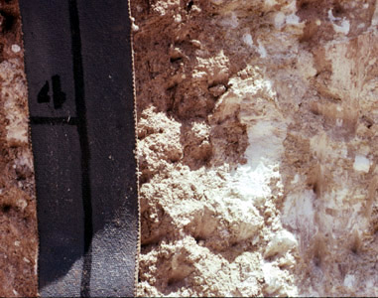
Masses are noncemented bodies of accumulation of various shapes that cannot be removed as discrete units, and do not have a crystal structure that is readily discernible in the field (10X hand lens). Their composition may be similar to or considerably different from the surrounding soil matrix. This includes finely crystalline salts and Redox Concentrations that do not qualify as nodules or concretions. Most are composed of Fe and Mn oxides, calcium carbonate, fine gypsum, or water soluble salts (halite, etc.).
Calcium carbonate masses (white areas)
Fe oxide masses (red areas)
Nodules and concretions - Nodules are cemented bodies of various shapes (commonly spherical or tubular) that can be removed as discrete units from soil. Crystal structure is not discernible with a 10X hand lens. Concretions are cemented bodies similar to nodules, except for the presence of visible, concentric layers of material around a point, line, or plane. The terms “nodule” and concretion” are not interchangeable. The composition of nodules and concretions may be similar to surrounding soil or greatly different.
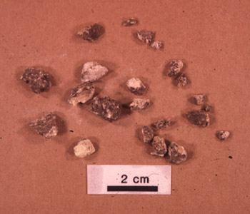
Calcium carbonate nodules
Crystals are macro-crystalline forms of relatively soluble salts (e.g., halite, gypsum, carbonates) that form in situ by precipitation from soil solution. The crystalline shape and structure is readily discernible in the field with a 10X hand lens. Crystals of gypsum often occur as concentrations in coarse pores.

Biological Concentrations are discrete bodies accumulated by a biological process (e.g., fecal pellets), or pseudomorphs of biota or biological processes (e.g., insect casts) formed or deposited in soil.

Inherited Minerals are field-observable particles (e.g. mica flakes) or aggregates (e.g. glauconite pellets) that impart distinctive soil characteristics and formed by geologic processes in the original Parent Material and subsequently inherited by the soil rather than formed or concentrated by pedogenic processes.

Plinthite - a special case Fe oxide concentration. It is defined as a Fe rich, humus poor mixture of clay with quartz and other minerals. One way to think of plinthite is as a more advanced stage of development of a soft Fe oxide concentration. Fe oxides have accumulated to the extent that the Fe concentration is cemented and the concentration is coherent enough to be separated from surrounding soil. However, the degree of cementation is such that the plinthite body can be broken between the fingers. Plinthite may occur either as irregular equidimensional bodies or in a platy form. Plinthite formation is commonly associated with soil horizons subject to frequent short duration saturation and redox cycles.

Ironstone - is similar to plinthite but has a greater degree of cementation and is harder. It can also be separated from the surrounding soil but cannot be broken between the fingers. Ironstone is thought to form from plinthite with repeating wetting and drying and exposure to air. Fe oxide masses (soft redox concentrations), plinthite, and ironstone can be thought of as a continuum. From the initial stage as a soft Fe concentration, development proceeds to plinthite and on to ironstone. In most cases, the Fe concentration increases as the concentration develops from a soft mass to plinthite. However, an Fe increase may or may not occur between plinthite and ironstone. The difference in hardness may be related to changes in crystal size and orientation.

Any number of properties of concentrations can be described. The most commonly described characteristics include amount, size, shape, consistence, color(s), kind and location.

The importance of concentrations is mostly interpretation of parent materials and soil development. Calcium carbonate and/or gypsum concentrations may indicate the average (or maximum) depth of leaching of the soil in semi-arid and arid climates. Fe oxide concentrations form in response to seasonal saturation of the horizon and thus, suggest the horizon is seasonally saturated. High concentrations (>10-15%) of plinthite may form a water/root restrictive layer.

PED SURFACE FEATURES

These features are coats/films or stress features formed by translocation and deposition, or shrink-swell processes on or along ped and coarse pore surfaces.
Three general types of features are found.

Coatings of material unlike the soil matrix such as clay, Fe and Mn oxides, organic matter, and calcium carbonate. These are formed by illuviation from overlying horizons or redistribution within a horizon.

Material concentrated on ped surfaces by removal of other material such as sand and silt coatings caused by clay removal by eluviation or dissolution.

Stress features which are commonly shiney ped faces and slickensides caused by mechanical stress associated with shrink-swell of the soil mass.

Ped surface features are described in terms of their amount, distinctness, color, texture, kind, location, and any other property that can be observed and is important.

Kinds of ped surface features:
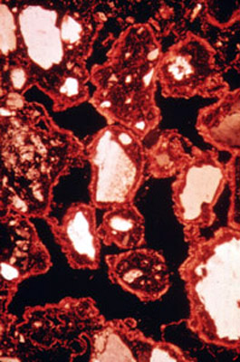
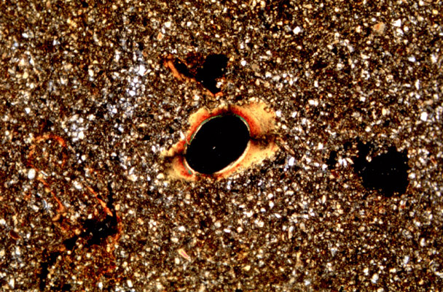
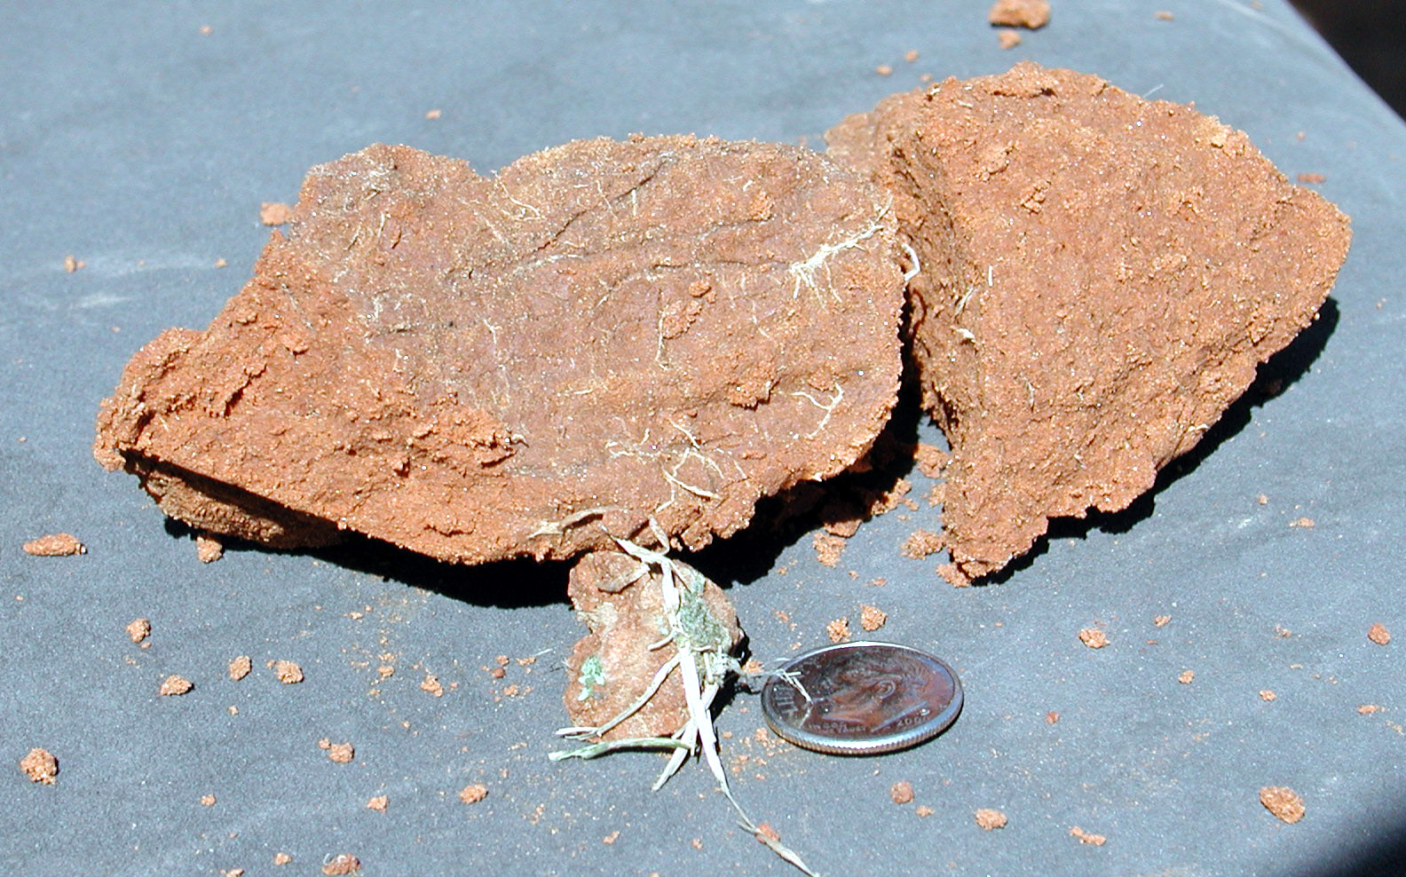
Clay films (clay skins, argillans) - thin coatings of oriented translocated clay
Thin section micrograph showing complete clay film coverage of strongly structured horizon (pores are black).
Clay film lining coarse pore (pore is black)
Peds with clay films on surfaces. The clay film is slightly darker than the ped interior.
Clay bridges - oriented clay linking grains at contact points

Sand or silt coats (skeletans) - sand or silt grains on ped surfaces. They may either form by translocation or by residual accumulation as clay is removed by eluviation or dissolution.

Other coatings such as coatings of Fe and Mn oxides, organic matter, soluble salts, or carbonates. They may result from translocation or from precipitation from solution.

Stress surfaces - smoothed ped faces caused by stress resulting from pressure generated as dry soil swells as it becomes wet.

Slickensides - stress surfaces that are polished and striated. Slickensides result from soil movement (surfaces sliding one over the other) as the soil shinks and swells with wetting and drying.
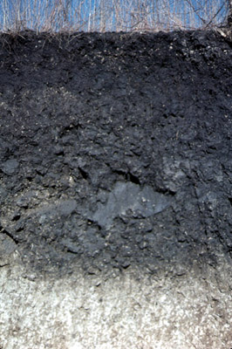
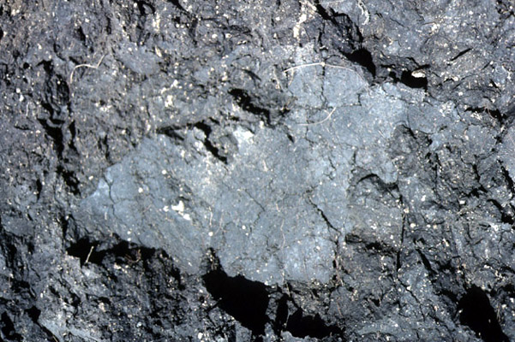

Slickenside in a high shrink-swell soil in Texas. Right photo is close-up of slickenside.

PORES, ROOTS, AND ANIMALS

Description of pores in horizons includes matrix, non-matrix, and inter-structural pores.

Matrix pores are formed by packing of primary particles or may be the result of entrapped air. These pores, especially coarser ones, are easy to see and describe but may or may not be continuous. Thus, they may have only a minor effect on movement of water and air through the soil.

Non-matrix pores are pores formed by actions of roots and animals. They are commonly relatively large and continuous, at least for a short distance. They may have an appreciable impact on water movement rates under saturated conditions.

Inter-structural pores are pores that occur between peds in structured soils. They are commonly relatively large and continuous, and they may form a extensive network for transmission of air and water through the soil. In soils with moderate or high shrink-swell, the effectiveness of these pores for transmission of water under saturated conditions is greatly reduced as the soil swells and the pores collapse.

Descriptions of pores can include quantity, size, location, and vertical continuity.

Roots are described in terms of their quantity, size, and location

Importance: lack of roots in horizons may be indicative of unfavorable physical or chemical conditions for root growth. Location of roots within the horizon may be indicative of high bulk density or cementation within the horizon that may limit rooting.

Features related to animal activity (burrows, mounds, castings, etc.) should be described if important.

Animal burrows (biopores) are described with the same terms as pores. Other animal features (castings, mounds, etc.) have no special terms for description but should include amount, location, size, shape, arrangement, color, etc.
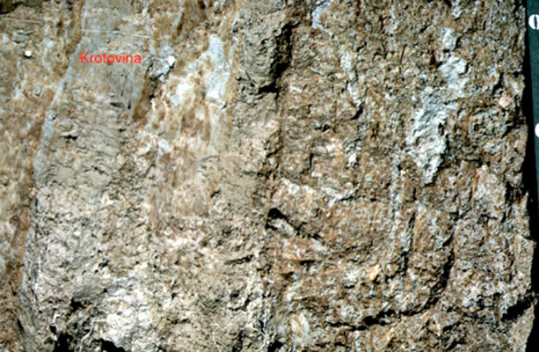
Krotovina is a special term for a coarse infilled animal burrow. A krotovina is an irregular tubular body most often associated with animals larger than earthworms and insects, i.e. crayfish, gophers, and other burrowing animals. The infilling is often material from an overlying horizon, and its texture, color, and structure may be greatly different from the horizon matrix.

Importance: Animal burrows create large pores for rapid movement of water, gases, and solutes through the soil. Extensive mixing by burrowing animals also can destroy evidence of horizon formation. The structure of some surface horizons is formed entirely by animal (earthworm) activity. Animal activity is also a major process in the development (or lack of development) of some soils.

ROCK FRAGMENTS

Other than amount and size, the characteristics of the fragments that are described depend on the purpose of the description and the skill of the describer.

Rock fragments may also be referred to as coarse fragments or simply as fragments.

HORIZON BOUNDARY

The horizon boundary refers to lower boundary of horizon being described and is intended to estimate the thickness and shape of the transition from the horizon being described to the subjacent horizon.

The horizon boundary is described in terms of its distinctness (thickness of transition) and topography (deviation from a plane).

The boundary between two horizons may affect water movement and rooting, especially if the two horizons have greatly different texture, structure, or consistence and the boundary is abrupt.

